CROSSTONGUEGUARD: DETECTING CYBERBULLYING IN CODE-MIXED CONVERSATIONS

Kadaganchi Sudhakar
Assistant Professor,
Department of Computer Science and Engineering (AI & ML),
Vignan Institute of Technology and Science, Nalgonda, Telangana-508284
Email:sudha143.su@gmail.com
Karamkonda Srinadh
UG scholar,
Department of Computer Science and Engineering (AI & ML),
Vignan Institute of Technology and Science, Nalgonda, Telangana-508284
Email:srinadhkaramkonda@gmail.com
Nakka Upender Goud
UG scholar,
Department of Computer Science and Engineering (AI & ML),
Vignan Institute of Technology and Science, Nalgonda, Telangana-508284
Email:nakkaupendergoud@gmail.com
Pathlavath Bhaskar
UG scholar,
Department of Computer Science and Engineering (AI & ML),
Vignan Institute of Technology and Science, Nalgonda, Telangana-508284
Email:bhaskarabdj123@gmail.com
Bhogolu Denesh Kumar
UG scholar,
Department of Computer Science and Engineering (AI & ML),
Vignan Institute of Technology and Science, Nalgonda, Telangana-508284
Email:deneshkumar248@gmail.com

Abstract—Cyberbullying has emerged as a recent concern in the global online communication platform, causing emotional distress and psychological trauma to individuals. The detection of cyberbullying is particularly challenging in the multilingual code-mixed online social media communication platform, where individuals communicate in multiple languages in a single message and use informal language, transliteration, and regional slang. These language complexities reduce the efficiency of traditional text classification techniques. To address this challenge, this paper proposes Cross Tongue Guard, a systematic framework for the detection of cyberbullying in multilingual code-mixed communication platforms. The framework employs systematic preprocessing techniques, semantic context-based annotation, and multi-aspect analysis based on intent, harm, and aggression. The framework integrates traditional machine learning models and multilingual transformer models to efficiently extract both statistical and contextual features. The primary aim of this research is to develop a scalable and language-agnostic cyberbullying detection framework that can handle real-world multilingual social media data efficiently and establish a safe online communication environment.
Keywords—Code-ixed, Semanticannotation, Multilingual Transformer Models, Contextual Features, Multilingual Social Media data, Intent, Harm, Aggression

Introduction
The rising trend of social media platforms has resulted in a paradigm shift in online communication, enabling people to communicate with each other in real time despite their geographical and linguistic differences. However, the online revolution has also led to a rise in the cases of cyberbullying, which is a form of online harassment that involves the use of offensive language, threats, humiliation, or intentional infliction of psychological distress through electronic communication services [1], [2]. Cyberbullying has been reported to result in severe psychological issues, including anxiety, depression, and social isolation, among the younger generation of people [3]–[5]. The requirement for automated detection of such negative behavior has thus become a significant area of research in natural language processing [6], [7].
The problem of detection becomes much more complex in a multilingual and code-mixed environment. In linguistically diverse regions, the user tends to switch between languages in a single message, resulting in a mixed-language text that includes transliteration, informal grammar, phonetic spelling, and regional slang [8], [9].
Recent advancements in the transformer model, particularly in BERT and its variants, have significantly improved the context-driven understanding of languages [10]–[12]. Cross-ling models such as XLM-RoBERTa [13] and region-specific models such as MuRIL [14] have shown outstanding performance in multilingual representation learning. Similarly, DeBERTa and its multilingual counterpart introduce novel disentangled attention mechanisms, which significantly improve the performance of context-driven modeling [15], [16].
However, despite such improvements, many existing studies on cyberbullying detection are still based on monolingual corpora or single-model solutions [2], [3]. Although recent studies have investigated transformer-based detection in the Hinglish code-mixed environment [13], [14], there is still a need for a holistic, end-to-end solution that includes structured preprocessing, semantic multi-aspect labeling, dataset balancing, and comparative model analysis. Moreover, some of the prevailing research works have concentrated more on the accuracy of the classification while paying less attention to the problem of imbalance, noisy transliteration, and the implicit forms of aggression in the context of a conversation. The absence of strong normalization techniques and the semantic alignment in the context of a multilingual scenario could influence the model’s ability to generalize.
To overcome these challenges, this paper proposes Cross Tongue Guard, a multilingual cyberbullying detection system for code-mixed social media interactions. The proposed system combines preprocessing and normalization strategies, semantic AI-assisted labeling for intent, harm, and aggression, exploratory data analysis, dataset balancing through under sampling, and traditional machine learning approaches along with multilingual transformer models. The main goal is to create a scalable and language-independent system that can enhance the performance of cyberbullying detection in a multilingual online setting.

Related work
Patchin and Hinduja [1] examined the psychological impact of cyberbullying and highlighted the need for automated systems to identify harmful online behavior. Kowalski et al. [2] further analyzed the long-term effects of digital harassment, emphasizing the growing scale of cyberbullying across social media platforms. Early computational approaches for detecting offensive content were introduced by Chen et al. [3] and Waseem and Hovy [4], who employed supervised learning techniques for hate speech classification. Davidson et al. [6] and Malmasi and Zampieri [7] explored machine learning-based detection methods using lexical and statistical features
Barman et al.'s research [9] focused on the challenges of language identification in code-mixed social media text, while Bandyopadhyay et al.'s research [8] addressed linguistic complexities, transliteration, inconsistent grammar, and phonetic spelling in multilingual communication. The aforementioned studies emphasize the constraints of traditional natural language processing approaches when processing content written in multiple languages.
Devlin et al. (2018) presented BERT, which significantly improved contextual language understanding using bidirectional transformer architectures. Liu et al. (2019) further improved the pre-training process to achieve superior performance using RoBERTa. Conneau et al. (2020) further advanced the work by introducing XLM-RoBERTa for large-scale cross-lingual representation learning. Khanuja et al. (2020) proposed MuRIL to suit Indian languages and code-mixed text. He et al. (2021) introduced DeBERTa using disentangled attention mechanisms, which was further extended to the multilingual space by Yang et al. (2022).

DATASET CONSTRUCTION AND PREPROCESSING
The effectiveness of any cyberbullying detection system depends on the quality, diversity, and representativeness of the dataset used for the purpose. In this study, a publicly available dataset was used, and it was processed to suit the purpose of multilingual cyberbullying detection. The dataset was reconstructed, refined, and analyzed to make it robust and reliable for the purpose.

Data Acquisition
The dataset used in the present study was retrieved from the publicly available cyberbullying dataset provided on the Kaggle platform. The dataset, after downloading, contained text data related to social media, with the text being labeled as either cyberbullying or not cyberbullying. The required columns of the dataset, related to text, were rearranged and placed in a newly formatted CSV file. The newly formatted CSV file was created for the specific requirements of the proposed project, and the dataset was used for all the steps of the project.

Data Cleaning and Preprocessing
Typically, the social media text data may contain noise, grammatical errors, special characters, URLs, hyperlinks, and unusual expressions. In order to ensure compatibility with the machine learning and transformer models, the dataset reconstructed underwent a series of preprocessing steps. The preprocessing steps involved the removal of URLs, special characters, and white spaces. In addition, all the text data were converted into lowercase, ensuring uniformity. Repeated characters and other formatting issues were resolved, thereby reducing the noise in the text data.

Semantic Context-Based Annotation

Nevertheless, the data set, despite having binary values, did not capture the more profound and intrinsic values that are relevant in the context of cyberbullying, such as intent, harm, and aggression. To enhance the data set semantically, the data annotation mechanism relied on the Large Language Model (LLM).

During the data annotation, the comments were analyzed using the ChatGPT model, and the comments were analyzed within a predefined structure. The model was set up in such a manner that the comments were analyzed on the basis of three different semantic attributes, namely intent, which indicated the intention behind the comments, whether it was meant to insult, threaten, or demean the victim; harm, which indicated the level of damage that could be inflicted on the victim; and aggression, which indicated the level of aggression in the comments. A binary label was determined on the basis of the comments and the evaluation mechanism. A uniform structure was used for the data annotation of all the comments. To enhance the accuracy level, the comments were manually evaluated.

Exploratory Data Analysis(EDA)
After the context-aware semantic annotation, Exploratory Data Analysis (EDA) was performed to identify the statistical properties of the data set. The primary goal of Exploratory Data Analysis was to evaluate the class distribution and relationships among attributes.

Class Distribution Analysis

From the diagram in Figure 1, we can see that the labeled data set is imbalanced, where the number of cyberbullying cases (Class 1) far exceeds the number of non-cyberbullying cases (Class 0). This could cause the model to favor the majority class, hence reducing the sensitivity of the model.
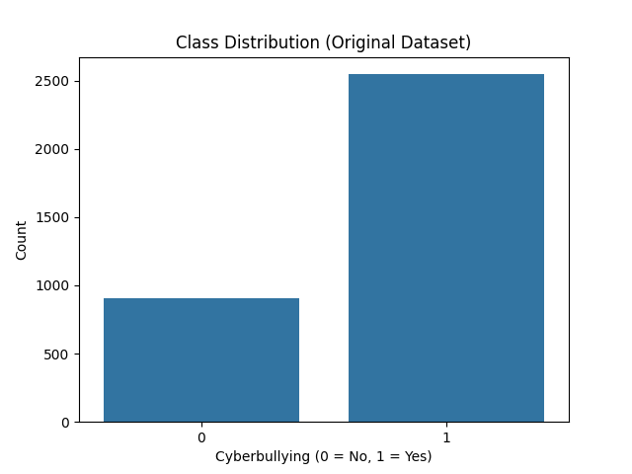
Figure 1-Class Distribution Analysis

Correlation Analysis
In order to determine whether basic structural features have a considerable impact on the classification of cyberbullying, a correlation analysis was conducted between text length and the cyberbullying classification, as depicted in Fig. 2. The correlation coefficient was found to be approximately 0.37, which indicates a moderate positive correlation between text length and the likelihood of cyberbullying. This indicates that longer comments have a higher probability of being related to bullying. However, it is also evident that the correlation is not substantial enough to be used as a discriminating factor, thus reinforcing the need for context-aware transformer-based models.
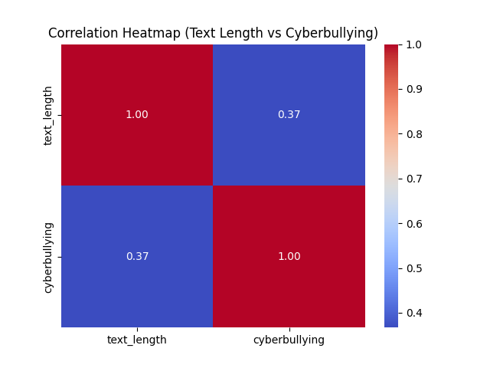
Figure 2-Correlation Analysis

Variability and Outlier Analysis

A box plot showing the text length distribution for the two classes is depicted in Figure 3. From the visualization, it can be seen that the median value of the text length for cyberbullying comments is considerably higher than that of non-cyberbullying comments. Moreover, there are a number of outliers in the case of the cyberbullying class, showing that there are messages with unusually long text.
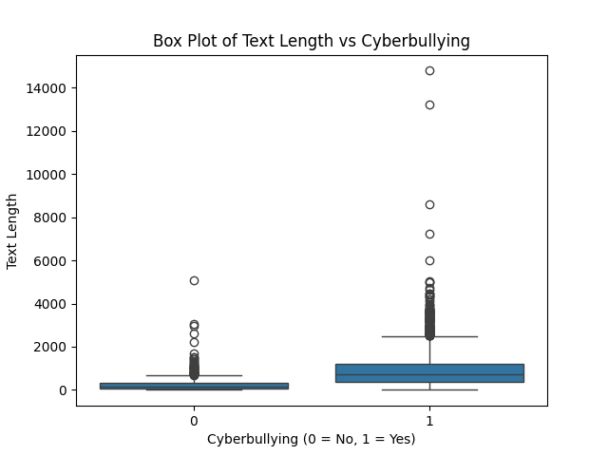
Figure 3-Variability and Outlier Analysis

Probability Density Distribution

The probability density functions (PDFs) of the length of the texts in the two classes are illustrated in Figure 4. The distribution suggests that the comments in the non-cyberbullying class are mainly concentrated in shorter length intervals, while the comments in the cyberbullying class have a wide range of dispersion with a long right-skewed tail. The overlapping sections of the two density graphs suggest that text length, on its own, cannot be used to differentiate between the two classes. This further justifies the need to employ sophisticated contextual embedding models to capture semantic variations beyond mere structural differences.

This elongation in the tail of the distribution for the cyberbullying category signifies that there is more variation and dispersion in the length of the comments. As a result, cyberbullying comments can be both short and offensive and lengthy and accusatory. Further, the overlapping density curves indicate that the length of the comment does not function as a discriminating factor. The fact that lengthy comments have a higher probability of being cyberbullying and that there is a degree of overlap suggests that semantic context is a key factor in the classification process.
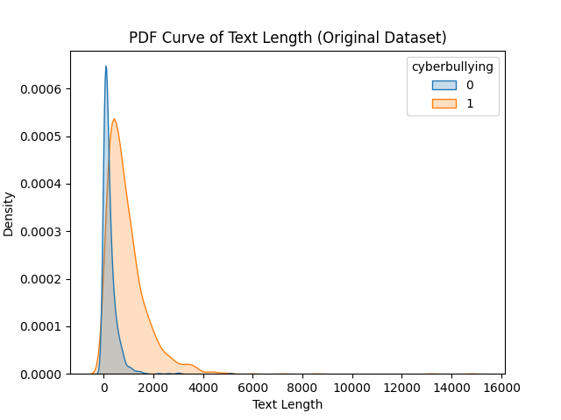
Figure 4-Probability Density Distribution Curve

Dataset Balancing

A class imbalance was noted in the above analysis, where it was seen that the dataset consisted of a larger number of samples from the class of cyberbullying when compared to the class of non-cyberbullying. It is widely accepted that class imbalance is detrimental to classification model performance, as it causes learning to favor the majority class, which negatively impacts the effectiveness of the model in generalizing and performing its task of detecting cyberbullying.

To solve this class imbalance problem, random under sampling was used to make the number of samples from the majority class equal to that of the minority class, where B_{Majority} and B_{Minority}are used to represent the number of samples from each class.
B|_{Majority} = B_{Minority}
resulting in a balanced dataset of size:
B_{Balanced} = 2 ×B_{Minority}

Algorithms used
The machine learning algorithms used in this study to detect cyberbullying are described in this section. TF-IDF features that were taken from previously processed textual data were used to create traditional classifiers. Comparing how well they were able to recognize cyberbullying content with semantic annotations was the aim.

LogisticRegression

Logistic Regression is a type of linear classification method that is supervised and used for classification problems having two classes. It was trained on balanced dataset by using TF-IDF extracted from the cleaned and semantically labeled dataset.
P (q= 1|p) = $\frac{1}{1+e^{-j^{T}p}}$
Where,
j = weight vector learned during training
p = TF-IDF Feature representation of the input text
Decision Rule is given by:
q| = $\left\{\begin{aligned}1 if P \left(q=1 | p\right)≥0.5 \\ 0 Otherwise \end{aligned}\right.$

Support Vector Machine

SVM was trained on the balanced cyberbullying dataset using TF, IDF features in this project. Because SVM can handle high, dimensional sparse data effectively it was expected to perform strongly in distinguishing subtle textual patterns associated with cyberbullying.

Optimization objective is:
min_{v.o}$\frac{1}{2} |\left|v\right||$²
is subjected to :
q_{i} (v^{T}p_{i} + o) ≥ 1
where,
q_{i}$∈\{-1.+1\}$
p_{i} = TF-IDF feature vector
v = normal vector to the hyperplane
o = bias term

Naive Bayes
Nave Bayes is a classifier that uses probabilities and is based on Bayes theorem with the assumption that features are conditionally independent. In this work, Multinomial Nave Bayes was used on the TF, IDF vectors of the labeled dataset. Because of its probabilistic character and ability to work well with sparse text features, it gave a pretty good baseline for the cyberbullying classification task.

From Bayes theorem
P (q|p) = $\frac{P\left(p | q\right) P(q)}{P(p)}$
For classification model,
q| = argmax_{q}P(q)$\prod_{i=1}^{n}{P(p_{i}|q)}$
where,
p_{i} represents individual TF-IDF features
P(q) = prior probability
P(p_{i}|q) = Likelihood

Transformer Models(MuRIL,XLM-RoBERTa,mDeBERTa)

To capture contextual semantics, three models were fine-tuned separately
- MuRIL
MuRIL (Multilingual Representations for Indian Languages) is essentially a transformer, based architecture that has been optimized for Indian languages as well as code, mixed text.Here MuRIL was fine, tuned on the semantically annotated cyberbullying dataset. Its multilingual pre-training is what makes it suitable for dealing with informal and mixed, language social media content.
- XLM-RoBERTa
XLM-RoBERTa is a sequence to multilingual transformer model that was trained on several large, scale multilingual corpora using masked language modeling.In this study, XLM-RoBERTa has been fine, tuned to perform a binary classification of cyberbullying.The model is able to leverage a cross, lingual contextual understanding thus accurately identifying the subtle patterns of aggression and intent in the texts.
- mDeBERTa
mDeBERTa enhances the DeBERTa model by adding disentangled attention mechanisms. Regular transformers combine content and positioninformation. Instead of that, mDeBERTa splits these two factors during the attention calculation, which results in better contextual representation.Here, mDeBERTa was fine, tuned to detect cyberbullyingby leveraging the balanced and semantically labeled dataset.
R = Mg_{CLS} + E
Predicted probability is computed using,
x| = $\ln{(\frac{d}{1-d})}$
where,
M and E are trainable parameters
g_{CLS} is contextual embedding
Binary Cross-Entropy loss was used for optimization:
K = -[xlog(x|) + (1-x) log(1-x|)]
where,
x| is predicted probability,
x$∈\{0,1\}$ represents ground truth label

Methodology
In this section, the proposed framework for cyberbullying detection created in this study will be discussed. The proposed framework combines structured feature extraction techniques with transformer-based models to identify cyberbullying content in textual data. The methodology used in this study focuses on transforming textual data into useful numerical representations, training classification models, and performing prediction tasks.

The framework that is being proposed includes a modular pipeline that is based on a well-balanced dataset. The initial stages of text processing include the use of feature extraction modules that convert text into numerical form. After that, the features are used for classification, which includes training. The trained models can then be used for the automated prediction of cyberbullying. The system architecture ensures that the data is processed in a consistent manner, which is a prerequisite for classification.
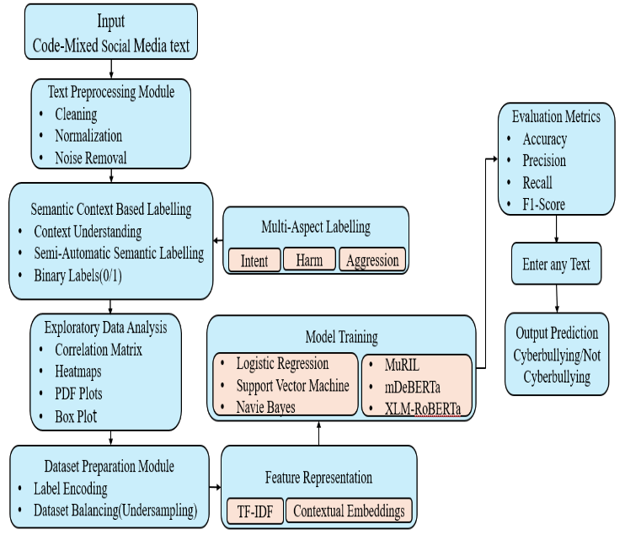
Figure 5-Model Architecture
Feature representation is a crucial step for text classification problems. In this study, two different feature extraction methods were employed: TF-IDF for conventional machine learning models and contextual representations for transformer-based models.
- TF-IDF Feature Representation
In the traditional machine learning pipeline, textual data is converted into Term Frequency-Inverse Document Frequency (TF-IDF) vectors. The TF-IDF score of a term q within a document r is defined as:
TF-IDF (q, r) = TF (q, r)×IDF (q)
Where,
TF (q, r) =$\frac{Frequency of q in r}{Total terms in d}$
IDF (q) = $\log\left(W\right)-\log\left(df\left(q\right)\right)$
Here,
W = Total Number of documents,
df (q) = The number of documents containing term q
- Transformer – Based Contextual Embedding

To better capture deep semantic relationships, multilingual versions of the transformer architecture like MuRIL, XLM-RoBERTa, and mDeBERTa were used. These models use self-attention mechanisms to generate contextual embeddings. Let’s assume that given an input token sequence:
S = {s₁, s₂, s₃, ……, s_{n}}
E = Transformer(S)
Self-Attention is Computed as:
Attention(Z, C, B) = SoftMax ($\frac{ZC^{Y}}{{√d}_{c}}$)B
Where,
Z = Query Matrix
C = Key Matrix
B = Value Matrix
This mechanism captures long-range dependencies and contextual interactions in the text. It enables each token to attend to every other token in the sequence..
Logistic Regression expressed the likelihood of cyberbullying as a sigmoid activation function over the linear combination of input features
Naive Bayes calculated the posterior probabilities by making feature independence assumptions. Support Vector Machine found an optimal separating hyper plane by maximizing the margin between the two classes of points. Besides the conventional machine learning, classifiers, transformer, based deep learning models were used to obtain contextual semantic representations of the text. Pre-trained models such as MuRIL, XLM, RoBERTa, and mDeBERTa were fine, tuned for the binary classification task. The contextual embedding of the classification token for each input sequence was passed to a fully connected layer followed by a sigmoid activation function to produce the final prediction probability.
Finally, performance evaluation was done through standard classification metrics such as Accuracy, Precision, Recall, and F1, Score. To understand the model behaviour and its discriminative capability, Confusion matrices and ROC curves were used

RESULTS
This section provides the results of the performance evaluation of conventional machine learning models and transformer, based architectures for cyberbullying detection under the newly proposed semantic context-based annotation framework. In order to have a fair comparison, all the models were trained and evaluated on the same balanced dataset and with the same train, test splits.

The functionalities of the Logistic Regression, Naive Bayes, and Support Vector Machine classifiers were tested using TF-IDF features. By taking advantage of the lexical patterns in the text, these models were capable of distinguishing cyberbullying from non, cyberbullying content at an effective baseline level of the traditional methods, Support Vector Machine showed relatively stronger discrimination ability because it is able to find the best decision boundaries in a high, dimensional feature space.

Transformer, based models such as MuRIL, XLM, RoBERTa, and mDeBERTa were fine, tuned using contextual embeddings. Such models were able to capture semantic dependencies and contextual nuances that go beyond what word frequency, based representations can achieve. Consequently, transformer architectures showed increased ability in identifying subtle forms of aggression, intent, and harm expressed in the text.

The confusion matrix is a tool that provides a detailed view of the classification results, such as true positives (TP), true negatives (TN), false positives (FP), and false negatives (FN). This kind of analysis helps in understanding the classification patterns and behavior of the model.
As mentioned in figure 6, Logistic Regression correctly classified 291 instances (TN = 155, TP = 136) but resulted in 45 false negatives, meaning that many instances of cyberbullying were classified as non-cyberbullying. Although the model performs decently, the slightly higher false negatives might affect its applicability in real-world moderation systems. The SVM classifier enhanced the separation of classes, obtaining TN = 159 and TP = 144 with fewer false positives (22) and false negatives (37). The property of maximizing margins in the high-dimensional feature space helps in better separation of classes. Naïve Bayes performed well in detection capability for cyberbullying instances (TP = 171, FN = 10), resulting in high recall. However, it resulted in 121 false positives, significantly affecting precision. This shows that the model over-classified the content as cyberbullying, which is likely due to the assumption of independence in the model.

MuRIL performed well in balanced classification results (TN = 157, TP = 146) with moderate false positives (24) and false negatives (35). The multilingual contextual embeddings used in the model help in better semantic understanding than traditional machine learning models. XLM-RoBERTa performed one of the best (TN = 157, TP = 151) with only 30 false negatives, meaning that the model has better contextual understanding and a strong cyberbullying detection capability. mDeBERTa performed competitively (TN = 159, TP = 138), although it resulted in slightly higher false negatives (43) than XLM-RoBERTa and MuRIL.
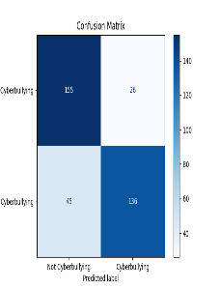  Logistic Regression | 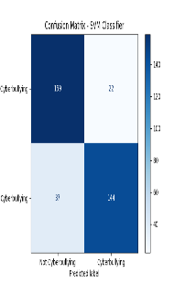  Support Vector Machine |  | 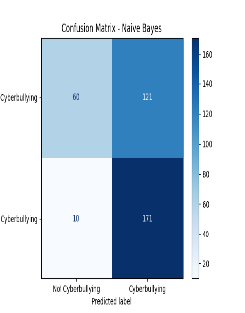  Naïve Bayes
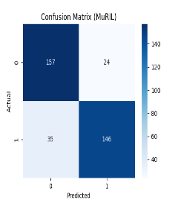  MuRIL | 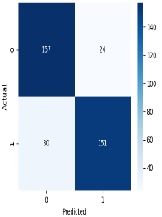  XLM-RoBERTa | 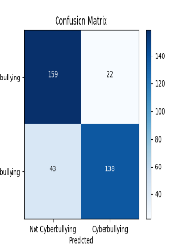  mDeBERTa
Figure 6 : Confusion Matrices of Trained Algorithms

Quantitative performance was assessed by metrics like Accuracy, Precision, Recall, and F1, score. Precision and Recall played a crucial role in this study because cyberbullying detection necessitates not only a reduction in false negatives but also a retention of the system's resistance against false positives. The F1, score gave a balanced view of the model's performance.

Table 1- Performance Comparison Table

Model | Accuracy | Precision | Recall | F1-Score
Logistic Regression | 0.80 | 0.83 | 0.75 | 0.79
Support Vector Machine | 0.83 | 0.86 | 0.79 | 0.82
Naïve Bayes | 0.63 | 0.58 | 0.74 | 0.72
MuRIL | 0.83 | 0.85 | 0.80 | 0.83
XLM-RoBERTa | 0.85 | 0.86 | 0.83 | 0.84
mDeBERTa | 0.82 | 0.86 | 0.76 | 0.80

XLM-RoBERTa had the highest overall accuracy of 85% and F1-score of 0.84. In the traditional machine learning models, SVM had the highest accuracy of 84% and F1-score of 0.83. Logistic Regression had a moderate F1-score of 0.79.Naïve Bayes had the highest recall of 0.94, which shows high sensitivity to the cyberbullying content. However, its precision of 0.59 was much lower, which shows a high false positive rate and lower reliability for use in real-world systems.The performance comparison graph (Fig. 7) further shows that transformer models have a clear edge over traditional models in most of the performance metrics.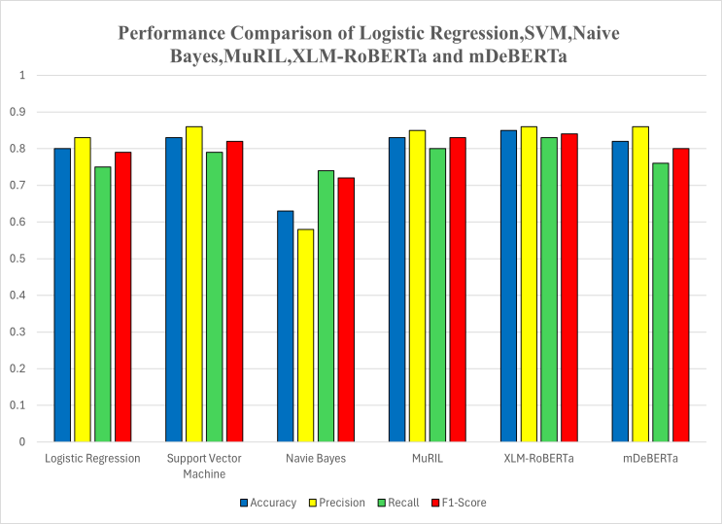
Figure 7 : Performance Comparison graph

The ROC curve illustrates the relationship between True Positive Rate (Recall) and False Positive Rate. As from the figure 8, the transformer-based models excel in distinguishing classes better than other machine learning techniques. XLM-RoBERTa dominates the chart by achieving the highest Area Under the Curve (AUC). This confirms that XLM-RoBERTa discriminates best among classes for different classification thresholds. MuRIL and mDeBERTa also achieve high AUC values, which validates the contextual embedding technique's effectiveness.

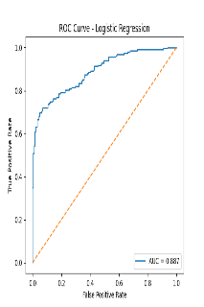  Logistic Regression | 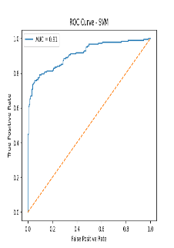  Support Vector Machine | 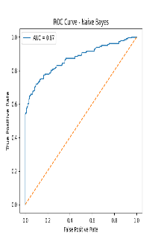  Naïve Bayes
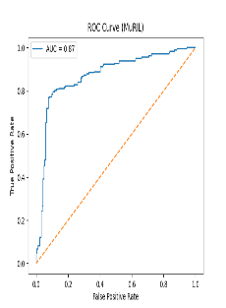  MuRIL | 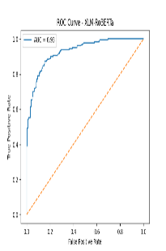  XLM-RoBERTa | 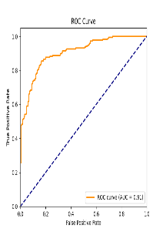  mDeBERTa

Figure 8 :ROC curves

The best classical models for classification are SVM, followed by Logistic Regression and Naive Bayes. Naive Bayes achieves a high recall rate but shows instability in the ROC curve, implying a higher rate of false positives.The higher AUC for transformer-based models validates their capability to comprehend contextual nuances such as sarcasm and aggressiveness inherent in cyberbullying.

The results show that contextual transformer models outperform traditional machine learning techniques by a good margin when it comes to detecting cyberbullying. Among them, XLM-RoBERTa emerges as the most balanced and reliable option, which not only offers high accuracy, a high F1-score, and a high AUC, but also manages to keep the false negative rate low. On the other hand, SVM emerges as a reliable baseline option, while Naïve Bayes seems to over-predict cyberbullying, making it less viable in real-world scenarios.

Overall, this proves that adding deep contextual representations can enhance the ability of the system to robustly and semantically detect harmful content.

Conclusion and Future work

This article presents a comprehensive comparative analysis of traditional machine learning classifier models and transformer-based models for cyberbullying detection. The traditional classifier models considered in this work are Logistic Regression, SVM, and Naïve Bayes. On the other hand, multilingual transformer-based models, such as MuRIL, XLM-RoBERTa, and mDeBERTa, are considered. The performance of each classifier was tested using accuracy, precision, recall, and F1-measure, confusion matrix, and ROC-AUC curve.

The experimental results show that transformer-based models perform significantly better than traditional classifier models in identifying the contextual and semantic nuances present in cyberbullying content. Among all the models considered in this work, XLM-RoBERTa was found to perform the best. It had the highest accuracy, F1-measure, and Area Under the Curve (AUC). Its low number of false negatives also makes it more reliable in identifying harmful content. Although SVM performed relatively well, Naïve Bayes performed well in terms of high recall value, its high number of false positives makes it less applicable. The results show that contextual embedding models perform significantly better than traditional frequency-based embedding models like TF-IDF.

Despite the high performance of transformer-based models, there are many opportunities and directions for further research.. Another direction is using hybrid models, which can be made by combining transformer embedding and other state-of-the-art models like attention. Another direction is using different optimization techniques like knowledge distillation, which can be used to reduce the complexity of the models. Another direction is using explainable AI, which can be used to improve transparency and interpretability.

This work presents a comprehensive comparative analysis of traditional classifier models and transformer-based models. It demonstrates the effectiveness of transformer-based models in identifying cyberbullying.

REFERENCES

- J. W. Patchin and S. Hinduja, “Cyberbullying and Self- Esteem,” Journal of School Health, vol. 80, no. 12, pp. 614–621, 2010.

- R. Kowalski, G. Giumetti, A. Schroeder, and M. Lattanner, “Bullying in the Digital Age: A Critical Review,” Psychological Bulletin, vol. 140, no. 4, pp. 1073–1137, 2014.

- C. Chen et al., “Detecting Offensive Language in Social Media,” ACL Workshop on Abusive Language, 2012.

- Z. Waseem and D. Hovy, “Hateful Symbols or Hateful People? Predictive Features for Hate Speech Detection,” NAACL, 2016.

- P. Badjatiya et al., “Deep Learning for Hate Speech Detection in Tweets,” WWW Companion, 2017.

- T. Davidson et al., “Automated Hate Speech Detection and the Problem of Offensive Language,” ICWSM, 2017.

- S. Malmasi and M. Zampieri, “Detecting Hate Speech in Social Media,” RANLP, 2017.

- S. J. Bandyopadhyay et al., “Code-Mixed NLP: Challenges and Resources,” LREC, 2018.

- A. Barman et al., “Code Mixing: A Challenge for Language Identification,” COLING, 2014.

- A. Conneau et al., “Unsupervised Cross-lingual Representation Learning,” ACL, 2018.

- J. Devlin et al., “BERT: Pre-training of Deep Bidirectional Transformers for Language Understanding,” NAACL, 2019.

- Y. Liu et al., “RoBERTa: A Robustly Optimized BERT Pretraining Approach,” arXiv preprint arXiv:1907.11692, 2019.

- A. Conneau et al., “Unsupervised Cross-lingual Representation Learning at Scale (XLM-R),” ACL, 2020.

- S. Khanuja et al., “MuRIL: Multilingual Representations for Indian Languages,” arXiv preprint arXiv:2103.10730, 2021.

- P. He et al., “DeBERTa: Decoding-enhanced BERT with Disentangled Attention,” ICLR, 2021.

- H. Yang et al., “mDeBERTa: Multilingual DeBERTa Model,” arXiv, 2021.

- https://www.kaggle.com/datasets/saurabhshahane/cyberbullying-dataset?select=youtube_parsed_dataset.csv

